Week 1:

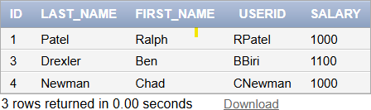

# SOWBARNIGAA SRIDHARAN

# 230701327

create table Employee_List (ID number(4), Last_Name varchar(25), First_Name varchar(25), Userid varchar(25), Salary number(9,2));

# BEGIN

insert into Employee_List values(1, 'Patel', 'Ralph', 'rpatel', 895); insert into Employee_List values(2, 'Dancs', 'Betty', 'bdancs', 860); END;

/

# BEGIN

insert into Employee_List values(3, 'Biri', 'Ben', '',1100 ); insert into Employee_List values(4,'Newman', 'Chad', '',750 );

insert into Employee_List values(5, 'Ropebur', 'Audrey', '',1550 ); END;

/

Update Emloyee_List set Userid=substr(First_Name,1,1)||substr(Last_Name,1,7);

select * from My_Employee;